INTEGRATION SCHEMA : -

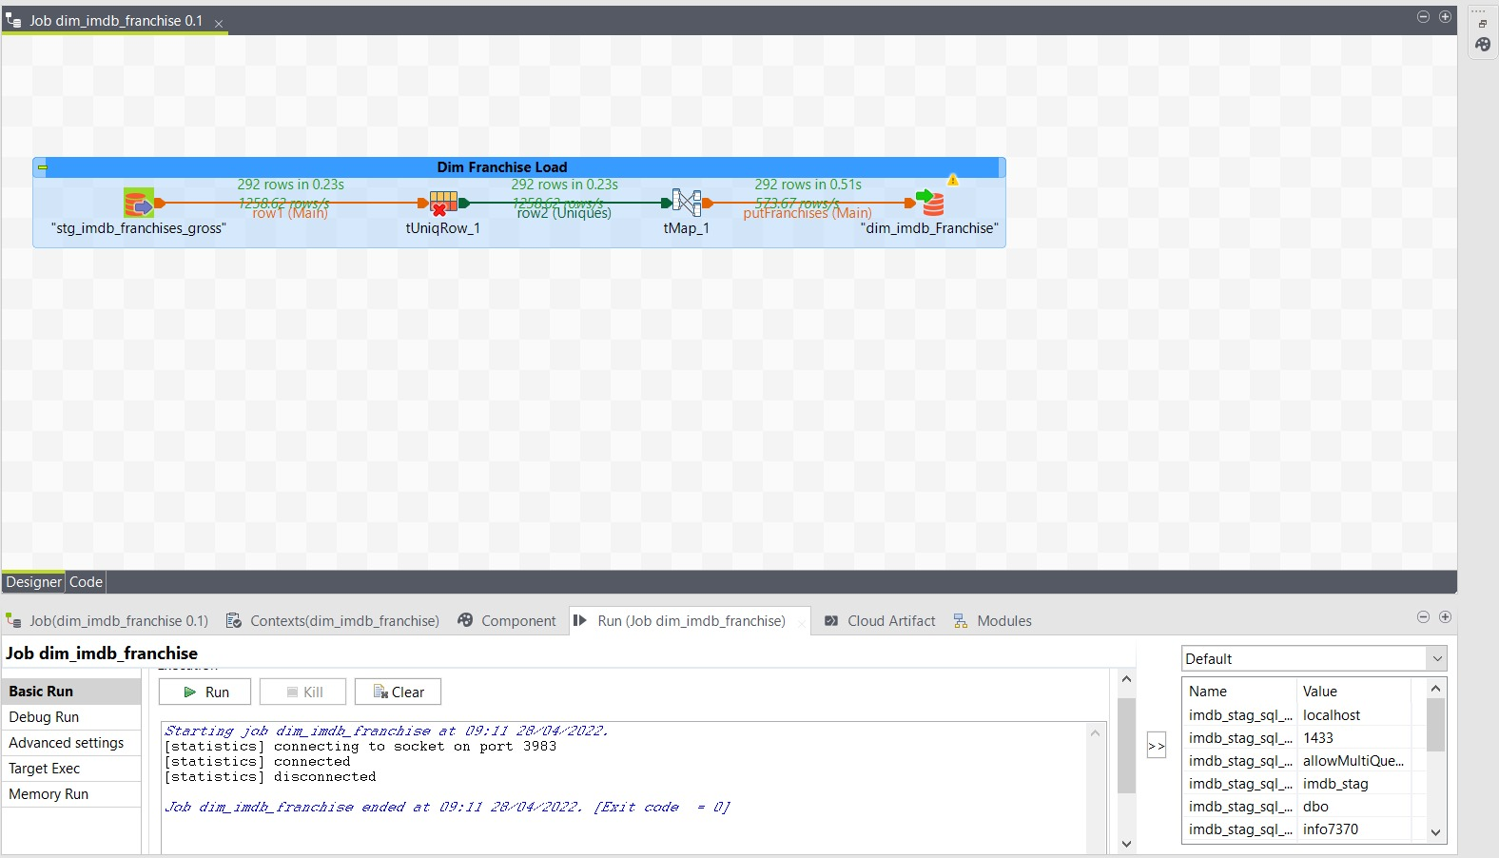

Job logs : -

